Project Design Phase-II

Data Flow Diagram & User Stories

|  |  |
| --- | --- |
| Date | 12 April 2025 |
| Team ID | SWTID1743512046 |
| Project Name | Tune Trails |
| Maximum Marks | 4 Marks |

**Data Flow Diagrams:**

A Data Flow Diagram (DFD) is a visual representation of the information flows within a music streaming system. It shows how music data, user

interactions, and content metadata enter and leave the system, what transforms the information, and where data is stored.

Level 0

Placeholder for Level 0 DFD showing main interactions between Users, Music Content, Streaming Service, and Database.

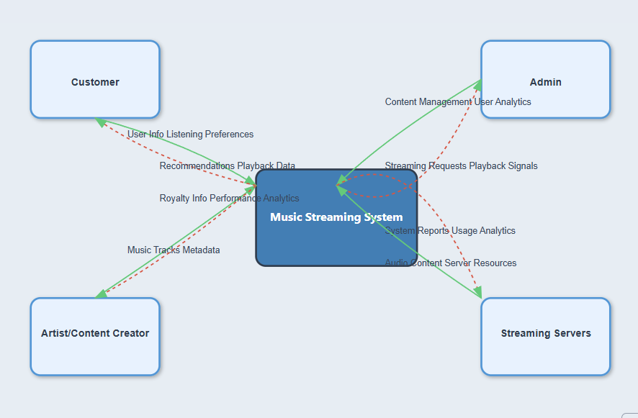

Level 1

Placeholder for Level 1 DFD detailing specific processes like User Registration, Music Playback, Playlist Management, etc.

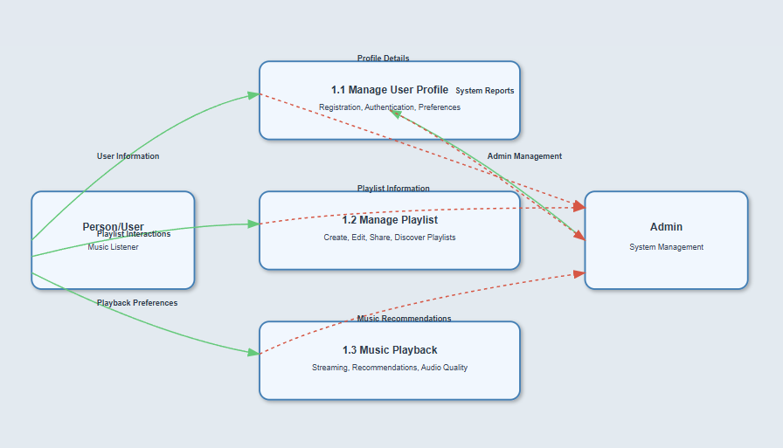

**User Stories**

|  |  |  |  |  |  |  |
| --- | --- | --- | --- | --- | --- | --- |
| **User Type** | **Functional**  **Requirement (Epic)** | **User Story Number** | **User Story / Task** | **Acceptance criteria** | **Priority** | **Release** |
| Music  Listener | User Registration | USN-1 | As a user, I can register for the application by entering my email, password, and confirming my password. | I can access my account / dashboard | High | Sprint-I |
| Music  Listener | Registration | USN-2 | As a user, I will receive a confirmation email once I have registered for the application. | I can receive  confirmation email &  click confirm. | High | Sprint-I |
| Music  Listener | Registration | USN-3 | As a user, I can register for the  application through Gmail. | I can register and access the dashboard using Gmail. | Medium | Sprint-I |
| Music  Listener | Login | USN-4 | As a user, I can log into the application  by entering email & password. | I can access my account/dashboard after login. | High | Sprint-I |
| Music  Listener | Dashboard | USN-5 | As a user, I can view my recently played  tracks and recommended playlists on the  dashboard. | I can see a list of recently played songs and personalized recommendations. | High | Sprint-II |
| Music  Listener | Playlist Management | USN-6 | As a user, I can create, edit, and delete  personal playlists. | I can create, modify, and remove playlists with ease. | High | Sprint-II |
| Music Listener | Content Management | USN-7 | As an artist, I can upload my music tracks, set metadata, and manage my artist profile. | I can add, edit, and remove my music content. | High | Sprint-III |
| Music Listener | Search & Discovery | USN-8 | As a user, I can search for songs, artists, albums, and genres. | I can find music through multiple search criteria with accurate results. | High | Sprint-II |
| Music  Listener | Playback | USN-9 | As a user, I can stream music with high-quality audio and minimal buffering. | I can play songs with smooth streaming and adjust audio quality. | High | Sprint-I |
| Music  Listener | Social Features | USN-10 | As a user, I can share playlists and songs with friends, and see what music my connections are listening to. | I can share music and view friends' musical activities. | Medium | Sprint-III |